How to get to the settings file in VS Code ...

You may have to dig through this to find how, but here is a quick way to do it, which is contained in the the above link (Ctrl + comma takes you there)

I did the following change to the VS Code settings file on 05-Mar-2024 . . .
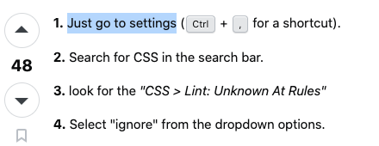
The above is how I fixed the problem with the “unknown at rules” in the global.css file, which also seems to have cured the problem of The resource <URL> was preloaded using link preload but not used within a few seconds from the window's load event

